**Room N-13 Specials**

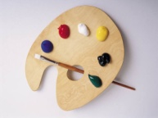Day 1 Art

9:00-9:40

j0186172

Day 2 Gym

9:00-9:40

j0199228Day 3 Library 9:00-9:40

Day 4 QUEST

9:00-9:40

j0237943

Day 5 Music 9:00-9:40